**MACROECONOMICS**

Microeconomics is concerned with the consumption and production decisions of individual consumers and producers (each single agent) and with the allocation of scarce resources among industries. At the time of the Great Depression in 1929, microeconomics was already well developed.

The failure to understand what caused the Great Depression (or how it could be tamed) was common at the time (1920-1930). The effort to understand economic slumps and find ways to prevent them is at the core of macroeconomics (economy as a whole).

The Great Depression started in the United States after a major fall in stock prices that became worldwide news with the stock market crash of October 29, 1929 (known as Black Tuesday). Between 1929 and 1932, worldwide gross domestic product (GDP) fell by an estimated 15%. Economies did not really know how to react. Some economies started to recover by the mid-1930s. However, in many countries, the negative effects of the Great Depression lasted until the beginning of World War II. International trade plunged by more than 50%. Unemployment in the U.S. rose to 25% and in some countries rose as high as 33%. Over time macroeconomics has broadened its objectives, such as long-run economic growth, inflation, and open-economy macroeconomics.

Before the Black Tuesday, the main wisdom in economics regarding employment and GDP could be resolved letting market forces work alone without government intervention (**self-regulating economy:**problems such as unemployment are resolved without government intervention through the working of the invisible hand). After 1930 it was clear that the economy could not reach equilibrium by itself and the conventional wisdom became the **Keynesian** view, according to which economic slumps are caused by inadequate spending, and they can be mitigated by government intervention, which had to implement fiscal policies that boost consumption. Consumption plays an important role in GDP, since consumers are also individual who both spend money and are active as workforce.

This view of government intervention in economy started in 1936, when the British economist John Maynard Keynes published *The General Theory of Employment, Interest, and Money,* a book that transformed macroeconomics. Since the 1930s, the U.S. (and most national governments) uses tools to improve the economy. **Fiscal policy** uses changes in government spending and taxes to affect overall spending.

**Monetary policy** uses changes in the quantity of money to alter interest rates and affect overall spending.

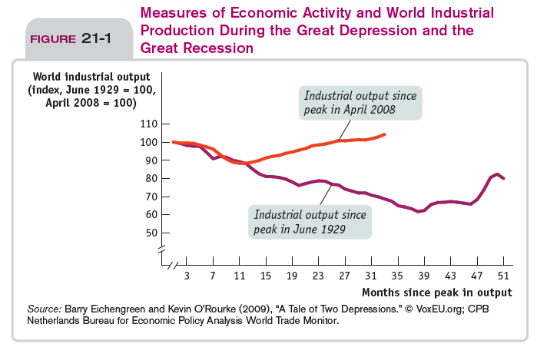Any time there is a recession, government tend to intervene in economy. In general Keynes established the idea that managing the economy is a governmental responsibility. Keneysian ideas continue to have a strong influence on both economic theory and public policy. In 2008-2009 (Great Recession) Congress, the White House, and the Federal Reserve took steps to fend off an economic slump.

Immediately after the peak of the recession, the two trends are identical, yet after one year we observe a decrease in world industrial output in 1929 and an increase in 2008: this is because macroeconomics and government intervention were well known in 2008, differently from 1929, when government had not a clear idea about how to react. Policy makers responded differently. During the Great Depression: some countries’ monetary authorities raised interest rates, Government cut spending and raised taxes. In the aftermath of the 2008 crisis interest rates were slashed, many countries increased public spending and reduced taxes and interest rates to provide incentives to invest again and reactivate the economy (expansionary fiscal policy and monetary policy).

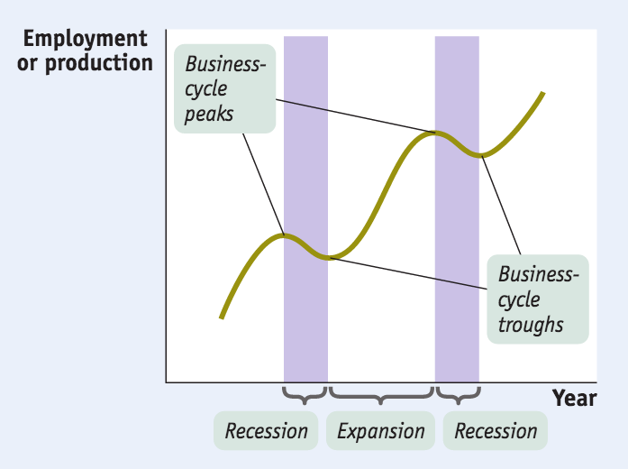Important in macroeconomics is the **business cycle**: the short-run alternation between **recessions** (**contractions 🡪**periods of economic downturn, when output and employment are falling) and **expansions** (**recoveries🡪**periods of economic upturn, when output and employment are rising). The point at which the economy turns from expansion to recession is a **business-cycle peak.** The point at which the economy turns from recession to expansion is a **business-cycle trough**. The immediate effect of recessions is the rise of unemployment: macroeconomists are interested in understanding and reducing it. The business cycle is a main concern of modern policy makers: they try to smooth out the business cycle. Even if you observe business cycles, what we notice is that the **long term trend** is actually an **increase** in output, employment and development (**positive long term trend**). This is important because GDP is correlated with other measures of development (e.g. development of human capital).

A rising overall level of prices is **inflation.** A falling overall level of prices is **deflation.** The economy has **price stability** when the overall level of prices changes slowly or not at all.

In the **short run** (months or few years),movements in **inflation** are **closely related to the business cycle**.When the economy is depressed and jobs are hard to find, inflation tends to fall; when the economy is booming, inflation tends to rise. In the **long run**, the overall level of **prices** is mainly determined by **changes** in the **money supply**.

Both inflation and deflation are problematic:

* **Inflation** discourages people from holding onto cash (because cash loses value if prices are rising 🡪 falling purchasing power). In extreme cases, people stop using cash altogether.
* **Deflation** can cause the reverse problem. Since cash gains value if the price level is falling, holding on to it is more attractive than investing in new factories and other productive assets. This can deepen a recession.

The United States is an **open economy**: it trades goods and services with other countries (**interaction**). In 2013, the United States ran a big trade deficit which, together with trade surplus, is typical of open economies.

* **Trade deficit:** the value of goods and services bought from foreigners is more than the value of goods and services sold to them.
* **Trade surplus:** the value of goods and services bought from foreigners is less than the value of the goods and services sold to them.

In the short run, deficit is not a problem because it is part of the business cycle, yet in the long run it increases debt and interest with it.

You can compare the sizes of two economies when they produce different things by comparing the value of their production. GDP (gross domestic product) is the most important and common way to estimate an economy’s size.

In most developed countries, the economic performance is measured by means of **national income** **and** **product accounts** (**NIPA**), controlled by statistical offices that keep track of different macroeconomics parameters used to measure the nation’s economic performance and track the economy’s condition throughout the business cycle (e.g. ISTAT in Italy).

A diagram shows the linkage between microeconomics and macroeconomics: in the analysis of consumers and producers, we have been focusing on households and firms that interact in the market for goods and services as well as inputs (both capital and labour). Households devolve consumer spending to the markets for goods and services which, in turn, are linked to firms through GDP. Firms interact with factor markets by means of wages, profit, interest and rent and factor markets interact with households through the same means. Households and firms interact also with other entities such as government, financial markets and the rest of the world. The government interact with households through taxes and government transfers and this interaction is important because governments are able to implement policies that are able to affect consumers through taxes, transfers and government spending. Government also interacts with the market for goods and services (purchasing items for itself), establishing a direct link that is important for the fiscal policy of the variation of government spending. The rest of the world is important for trade of both goods and services and financial markets: a country can borrow and lend money thanks to the financial market that regulates the link of a country with the rest of the world through financial assets. The link between households and financial markets is important because private savings are an important component of GDP.

The **gross domestic product** (**GDP**) is a measure of the market value of all final goods and services produced within a country in a given year.

* ***Produced:*** GDP measures production. Sale of used goods and of financial assets, such as stocks and bonds, are not included.
* ***Within a Country:*** only production that takes place within the borders of a country, independently from who is the owner of the firm, is included in GDP (e.g. cars produced in Mexico by American firms are not included in the US GDP; cars produced in the US by Japanese firms are included in the US GDP).
* ***In a* *year*:** GDP is like annual income, it measures production during a given period.

The use of GDP for measuring the wealth of a nation has some limitations: for example, it does not consider the value of goods and services that family members provide to each other, except for the estimated value of housing “services” for those that own their home (instead of renting). This underestimation is particularly impactful in countries as Italy, where most of the services are supplied by the family and most of the goods are produced at home.

GDP can be calculated in three ways:

* Adding up the **total value of all final goods and services produced**. It refers more to the supply side (supply-driven definition of GDP).
* Adding up **all spending on domestically produced final goods and services** (consumer-driven definition)**.**
* Adding up the **total factor income earned by households**from firms in the economy.

Usually statistical offices adopt all the three methods, which usually produce the same result. Why? Think about the first two definitions: they are a proof of the fact that **one person’s spending is another person’s income** and this works for the whole economy.

Stiglitz, a Nobel prize economists, worked on a project called *beyond GDP*, focused on the fact that GDP has lots of limitations and there should be more general methods to measure it, such as education, health (human capital), the quality of environment ecc.

There are two kinds of goods and services:

* **Final goods and services:** goods and services sold to the final, or end, user.
* **Intermediate goods and services:** goods and services (bought from one firm by another firm) that are **inputs** for production of **final goods and services.**

They are involved in the definition of the first method, focused on value added: **value added** of a producer is the value of its sales minus the value of its purchases of intermediate goods and services.

As for the second method, we have to consider all parts of spending:

**GDP = C + I + G + X – IM**

Where C stands for consumer spending (both physical and human capital/assets), I stands for investment spending (physical assets), G stands for government purchases of goods and services, X stands for sales to foreigners and IM stands for imports (purchases of foreign goods or income that has leaked across national borders. The difference between X and IM represents the net export.

What is the relationship between the first and the second method?

The value of the GDP is about the same, yet it does not correspond exactly.

As for the third method, it includes the value of remuneration of inputs used in the production process:

* **Wages** represent the remuneration of labour.
* **Rent** earned by those who lease their land or structures to firms (physical assets).
* **Dividends**, namely profits paid to the shareholders, the owners of the firms’ physical capital.

The second and the third represent the remuneration of the physical capital.

Considering a simple economy with only three firms operating, we exclude net export and we suppose that there is no government intervention.

Two out of three firms produce inputs and only the third one releases the final product. 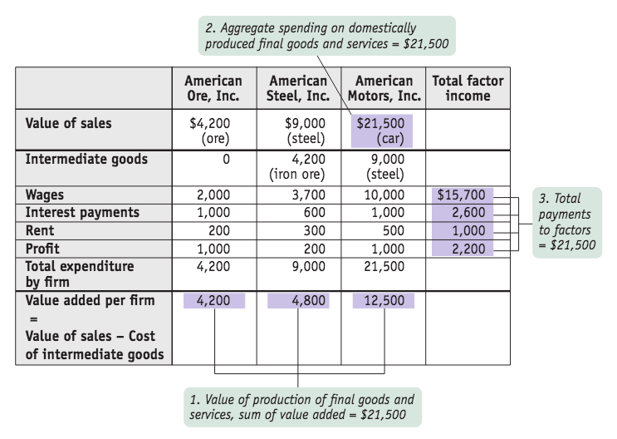The first company mines the iron, so there are no intermediate goods because it extracts the input. This company must pay wages to workers and needs to repay the interests to a bank. Moreover, it has to pay a rent and a profit to the owner to the owner of the company. Its total expenditure is 4200: since there are no intermediate goods, the value added for production is exactly the value of the good produced by the company (4200). As for the second company, it buys the iron to produce steel and therefore we have to consider a value of 4200 dollars that it has to pay to the first company to make the purchase. Moreover, it hires workers (🡪 wages) and has to pay rent, interests and profit, so that its total expenditure is 9000. However, in the calculation of GDP we have to subtract the value of the intermediate goods, so that the result is 9000 – 4200 = 4800. The steel produced by the second company, with a value of 9000, is bought by the third company as an intermediate good to produce the final good. Also the third company has to pay wages, interests, rent and profit, so that the total value of the good is 21.500. From this we have to subtract the value of the intermediate good, so that the value added is 21.500 – 9000 = 12.500. The value of production will be the sum of the three values added, namely 4200 + 4800 + 12.500 = 21.500. This is equal to the value of the final good because we are considering only one good and because we are ignoring government intervention and foreign trade. To calculate the GDP, we have to consider also the value of wages, rents, profits and interests for the three companies: if summed, they will result equal to 21.500.

Up to now, we have done no distinction between real GDP and nominal GDP:

* **Real GDP** is the total value of the final foods and services produced in the economy during a given year, calculated using the **prices** of a **selected base year** (arbitrary year needed in order to have a reference point). It is a better measure of GDP because it takes variation of prices into account.
* **Nominal GDP** is the value of all final goods and services produced in the economy during a given year, calculated using the **prices** **current** in the **year** in which the output is produce.

Sometimes nominal GDP seems to increase, differently from real GDP, because of inflation (increase in the general level of prices) 🡪 e.g. Venezuela.

Considering a simple economy that produces only two goods (apples and oranges), of which we know the prices, and two generic years, we can calculate nominal GDP by summing the values of both goods. The real GDP can be calculated by multiplying the quantities of year 2 for the prices of year 1 (value of output in year 2 expressed in year 1 prices), obtaining a lower result because from one year to the other the prices of both goods have increased.

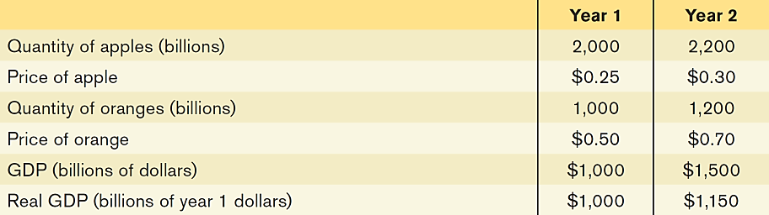  
To establish the prices, there is a basket of consumption and economists consider the proportion between production and expenditure, the composition of the basket and other factors.

GDP, either real or nominal, may be an imprecise way to measure the wealth of a nation. According to Stiglitz, other factors such as sustainability, human capital and environmental resources should be taken into account; in his project, he introduced a **Human Development Index** that emphasizes that outcomes for people and their capabilities should be the ultimate criteria for assessing the progress of a country as well as economic growth and monetary components. The HDI accounts for average achievements in three main dimensions:

* **Health/life expectancy** (proxy for leading a long and healthy life 🡪 human capital).
* **Education** (proxy for being knowledgeable 🡪 human capital).
* **Income per capita** (usually GDP per capita; proxy for command over resources to have a decent standard of living).

A standard definition of human development (1990 HDR) is:

*“[…] a process of enlarging people’s choices to live lives they have reason to value… The most critical ones are to lead a long and healthy life, to be knowledgeable and to enjoy a decent standard of living.”*

A broader definition (2010 HDR):

*“Human development is the expansion of people’s freedoms to live long, healthy and creative lives; to advance other goals they have reason to value; and to engage actively in shaping development equitably and sustainably on a shared planet”*

Another index that provides a graphical representation of the wealth of a nation is the tree index: the number and colour of leaves and the height and width of the trunk represent different factors involved in the evaluation of the wealth of a nation.

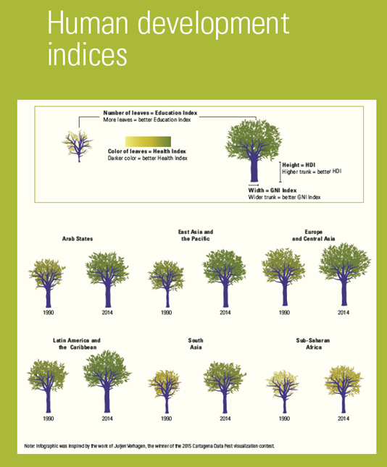

**PRICE INDEXES**

In reality, we consider aggregate price levels rather than prices of single goods.**Aggregate price level** isa measure of the overall level of prices in the economy. To measure the aggregate price level, economists calculate the cost of purchasing a **market basket**,a hypothetical set of consumer purchases of goods and services.

*Cost of a market basket:*

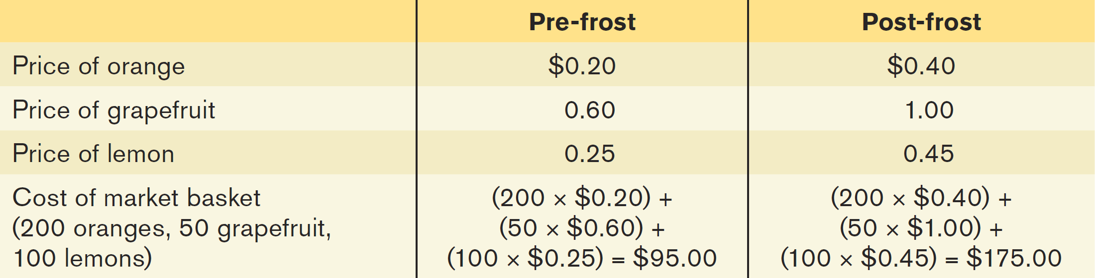

To have a price index, we have to consider the aggregate price level is different years. **Price Index** isthe cost of purchasing a given market basket in a given year, where that cost is normalized so that it is equal to 100 in the selected base year. It is the ratio between the cost of market basket in a given year and the cost of market basket in a base year multiplied by 100.

$Price index in a given year=\frac{cost of market basket in a given year}{cost of market basket in base year}×100$

**INFLATION RATE AND CPI**

The **inflation rate** isthe yearly percentage change in a price index, typically based upon **consumer price index**, or **CPI**, the most common measure of the aggregate price level. The **consumer price index**, or **CPI**,measures the cost of the market basket (composed by several goods) of a typical urban family of a specific country.

$Inflation rate=\frac{price index in year 2-price index in year 1}{price index in year 1}×100$

In reality, the only difference with respect to a simplified economy is the fact that we consider market baskets made up of base goods.

As well as CPI, an important price index is the **producer price index** (**PPI**), which measures changes in the prices of goods purchased by producers.It usually considers the price levels of intermediate goods, namely those goods used as inputs in other production processes.

Economists also use the **GDP deflator,** which measures the price level by calculating the ratio of nominal to real GDP. The GDPdeflatorfor a given year is 100 times the ratio of nominal GDP to real GDP in that year. Although not an index, it is a proxy of inflation rate because comparing nominal and real GDP allows to calculate how prices change. The flow of CPI, PPI and GDP deflator is usually very similar, so they are closely interrelated. Moreover, PPI is more sensitive (both positively and negatively) to external changes (e.g. inputs of production), since it increases more than the other two measures. Finally, the CPI seems to be well correlated to the GDP deflator.

**INFLATION AND DEFLATION**

Inflation and deflation have costs. The costs associated to inflation are divided in three categories:

* **Shoe-Leather costs:** costs associated to money. They are the increased costs of transactions caused by inflation, caused by a decreasing purchasing power. Since cash loses its value quickly during high inflation, people waste more time running around to spend it as fast as they can for consumption purposes.
* **Menu costs:** the real cost of changing a listed price. When inflation is very high, prices must be changed frequently and, in order to avoid menu costs, a country may decide to link the national currency to other more stable currencies (e.g. Zimbabwe in 2008, Israel in mid-1980s).
* **Unit of Account costs:** costs arising from the way inflation makes money a less reliable unit of measurement. Calculations are hard when inflation is high. The effect is to reduce the quality of economic decisions: the economy as a whole makes less efficient use of its resources because of the uncertainty caused by changes in the unit of account. Unit-of-account costs may be particularly important in the tax system because inflation can distort the measures of income on which taxes are collected.

*e.g.* Assume that the inflation rate is 10%. Suppose that a business buys an asset, such as a piece of land, for $100,000, then resells it a year later for $110,000. In real terms, the business did not make any profit. However, the tax law would say that the business made a capital gain of $10,000, and it would have to pay taxes on that phantom gain.  
Another way in which inflation causes unit-of-account costs is in the credit market.

The **interest rate** is the return a lender receives for allowing borrowers the use of their savings for one year, calculated as a percentage of the amount borrowed. **Nominal interest rate** isthe interest rate expressed in dollar (or any currency) terms. **Real interest rate** is the nominal interest rate minus the rate of inflation.

In the credit market, lenders and borrowers make an agreement based on **nominal interest rate** and on the **expectation** regarding **inflation rate**. What happens if the latter is different from the actual realization of inflation rate? In this case, there will be **winners** and **losers** depending on whether the **current inflation rate** is higher or lower than expected. If it is higher, borrowers gain because they will have to pay an amount of money whose real value is lower than expected, so theygain at the expense of lenders: borrowers will repay their loans with funds that have a lower real value than had been expected. Conversely, if the inflation rate is lower than expected, lenders will gain at the expense of borrowers: borrowers must repay their loans with funds that have a higher real value than expected.